Snap2DIVERSE: Integrated Venues
for Information-Rich Visualization of Chemical Data

Nicholas F. Polys npolys@vt.edu
Maxim Moldenhauer mold@vt.edu

Andrew Ray anray2@vt.edu
Chetan Dandekar chetan@vt.edu

ABSTRACT
A considerable amount of work has been done in the field of visualizing chemical compounds and there have been several types of visualization and interaction implemented and evaluated in 3D and immersive environments in this area. While prior work has elucidated design criteria for 2D or 3D information visualizations, little of this work addresses the combination of embedded, coordinated 2D visualizations in an immersive environment. The challenge unique to our project is how software and communication architectures can work together to support coordinated displays and interactions across rendered dimensions. Our work extends previous research by having 2D and 3D views of the molecular data linked across Snap and DIVERSE platforms. 2D data about a molecules and its atoms is viewed through Snap while the 3D structure will be viewed in DIVERSE, specifically the CAVE. This requires the sharing of addressible data objects and event communication across the applications. Across these coordinated visualizations in an immersive space, we demonstrate visualization tasks such as Overview/Detail, Selection, and Manipulation and identify usability issues that may guide future work.

Keywords
Information visualization, immersive systems, molecular graphics

1 INTRODUCTION & BACKGROUND
In many cases of data and domain, the nature of the data, especially its semantics and dimensionality, may determine the most ‘appropriate’ rendering (2D or 3D) and interaction scheme. In modern design and research applications, a significant proportion of data concerns geometrical and structural information as well as associated abstract or quantitative about that geometry. For example, in the domain of chemical engineering and biomedical designers, chemical data is multi-facted: structural, nominal, ordinal, and quantitative data (such as their physical characteristics) are associated to molecules and their constituent atoms and bonds.
Immersive Virtual Environments (VEs) excel at providing researchers and designers a greater comprehension of the spatial features and relations of their data, models, and scenes. However, there is a lack of documented techniques to embed tightly-coupled 2D visualizations in immersive environments.
Established information visualization techniques for 2 dimensional displays include textual/tabular renderings, scatterplots, barcharts, linegraphs, piecharts, etc. and each may be useful to show different qualities and relationships in the dataset [CMS99]. In these contexts however, inherently spatial data such as the structure of atoms and bonds in a molecule is difficult to understand and 3D views may be required. In order to understand and integrate both these types of data, they must be simultaneously available to the user. While our project can be run on a desktop with 2D and 3D views in separate windows, we are interested in embedding coordinated 2D visualizations inside a 3D world such as the in the CAVE. Typically in the literature, visualizations are described and categorized per-user-task such as exploring finding, comparing, and recognizing (patterns). These tasks are common in information-rich virtual environments as well. The principle technologies used in our implementation (Figure 1) are described below.
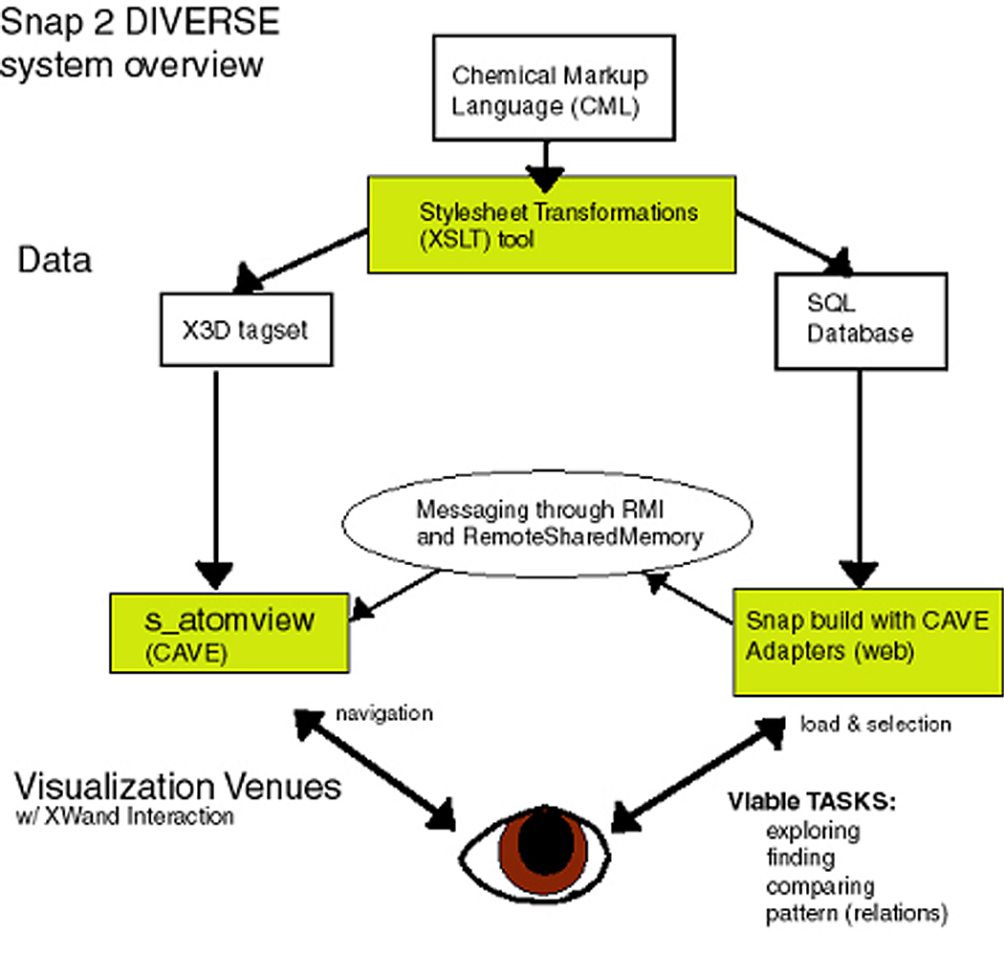Figure 1. System Architecture

1.1 Chemical Markup Language (CML)
CML is a new approach to managing molecular information. It has a large scope as it covers disciplines from macromolecular sequences to inorganic molecules and quantum chemistry. CML is new in bringing the power of XML to the management of chemical information -its design supports interoperability with the XML family of tools and protocols. CML contains a number of kinds of information about a particular compound, from its physical atomic structure and elemental makeup to its water solubilty, melting point, atomic weight, and various spectral descriptions. These are manifested by variety of data-types in tags describing structural, numerical, and meta data about the chemistry of the molecule. Thus CML provides a base functionality for atomic, molecular, and crystallographic information and allows extensibility for other chemical applications.
Dr. Peter Murray-Rust, Dr. Henry Rzepa, Dr. Michael Wright, and the other developers of CML have provided a DTD, Schema, and an API toolkit (CMLDOM). In addition, they provide Jumbo, a Java-based application to load and view a number of chemical formats in CML (CIF, MDL, MOL2, PDB, XYZ JMOL) and write them out to any of those formats. Given the capability and flexibility of CML to describe molecular information, and the wide support for XML tools we chose to source our data in this format.

1.2 Extensible Markup Language (XML) and Extensible Stylesheet Transformations (XSLT)
Numerous developer resources exist for the World Wide Web Consortium’s XSLT specification [W3C] so we will focus on the design issues specific to CML and transformation to X3D and relational tables. However, a review of the typical XSL Transformation process is in order:
- An XSLT engine parses the source XML document into a tree structure its various nodes.
- The XSLT engine transforms the XML document using pattern matching and template rules in the style-sheet (.xsl);
- Template elements and attribute values replace matched element/attribute patterns of the source document in the result document.
First, for each of our destination venues, we wrote a set of XSLT files specifying the proper attributes of the output method, encoding, media-type, and cdata-section-elements, and the DOCTYPE system for our result document.

1.3 Extensible 3D (X3D)
The Web3D Consortium’s next-generation successor to VRML is X3D which, like XML, moves beyond just specifying a file format or a language like VRML or HTML. It is a set of objects and interfaces for interactive 3D Virtual Environments with bindings defined for multiple profiles and encodings and collected under a standard API [W3D]. The X3D specification describes the abstract performance of a directed, a-cyclic scenegraph which can be defined by an XML binding using DTDs and Schema. In addition, rather than defining a monolithic standard, the X3D specification is modularized into components which make up ‘Profiles’. Profiles are specific sets of functionality designed to address different application domains from simple geometry interchange or interaction for mobile devices and thin clients to the more full-blown capabilities of graphical workstations and immersive computing platforms.
The X3D Task Group has provided a DTD, Schema, an interactive editor, and a set of XSLT and conversion tools for working with X3D and VRML97. The official file extension for X3D files is .x3d and the official MIME type for X3D files is defined as: model/x3d. While the structural geometry of the molecule could be described in X3D simply as primitives conforming to the Interchange Profile (Sphere, IndexedLineSet), our X3D data files for DIVERSE used high-level markup (Prototype tags) to describe the data in the scenegraph. This way, the displayed form of an atom or bond could be customized by the application (and atom as a Sphere, a bond as a line or cylinder).

1.4 Snap
Snap is a web-based interface for creating customized, coordinated, multiple-view visualizations. Through web pages and Java applets, Snap provides users with the ability to build layouts of multiple visualizations of data in a SQL database with components such as tables, scatterplots, barcharts, etc. Users can interactively combine visualization components and specify coordinations between visualizations for selecting, navigating, or re-querying. Thus Snap is flexible, allowing users to coordinate visualizations in ways unforeseen by the original developers. Additionally, Snap provides an interface for developers to build their own Snap Adapters to custom visualization components. We take advantage of this capability by defining the CAVE Adapter, a set of classes that process events from Snap and communicate them to the remote DIVERSE visualization.

1.5 DIVERSE
DIVERSE is a software toolkit for building portable virtual environement applications developed by the University Visualization and Animation Working Group at Virginia Tech. Our VE application is written for DIVERSE and extends AtomView, a molecular visualization tool for materials scientists also developed at Virginia Tech. DIVERSE provides some powerful advantages:
- A common user interface to interactive graphics and/or VE programs. Using DIVERSE the same program can be run on CAVETM, ImmersaDeskTM, HMD (head mounted display), desktop and laptop without modification.
- A common API to VE oriented hardware such as trackers, wands, joysticks, and motion bases.
- A "remote shared memory" facility allows data from hardware or computation to be asynchronously shared between both local and remote processes
- The DSO "plug-in" system that DIVERSE uses allows you to write one program which will run everything from a desktop workstation to a multi-walled CAVE. On each platform, it will use a display method and user interface appropriate to that platform.

1.6 XWand
XWand is a program that allows you to use an input device such as a wand to start, stop, and manipulate any application in XWindows. XWand works by using the DIVERSE Toolkit (DTK) to obtain input from devices in an immersive environment such as an iDesk or CAVE. It works by using XTest extensions in conjunction with input from DTK. In addition to the XWand program, there is also an XWand DSO that, when loaded into a DIVERSE application, can stop and start the navigation for the currently running application, giving the Xwand program control over the wand events.

2 RELATED WORK

2.1 Molecular Data & Graphics
Murray-Rust et. al. have described the basic concepts of CML in their paper [MRR99]. Also, they worked on a project [MRW01] culminating in the first fully operational system for managing complex chemical content entirely in interoperating XML-based markup languages. This involved the extension of CML 1.0 and the development of mechanisms allowing the display of CML marked up molecules, spectra and reactions within a standard web browser.
MICE [MICE] is a project that is developing new methods of collaborative, interactive visualization of complex scientific data. While most existing methods of representing scientific data are static and two-dimensional, the technologies being used and developed for MICE provide interactive, three-dimensional environments within which multiple users can examine complex datasets in real-time. The MICE application enables users to not only view molecular scenes on their own computer, but to distribute these scenes and interact with other users anywhere on the internet.
Design and implementation of a collaborative molecular graphics environment [TMB00] discusses a previously implement molecular graphics system which also provides capability for collaboration and interaction across networks. This suggests the idea of having multiple workstations all reading from the same memory with a teacher controlling what the students see. Its web-based system suggests some ideas for our own web-based implementation. Although we may not get to all the collaborative features, if any, they could be candidates for future additions to our project.
We plan on using a web based visualization system in addition to the 3D immersive view that the CAVE provides. ‘A Functional Framework for Web-Based Information Visualization Systems.’ [Bender00] deals exactly with what we are going to visualize. It gives good ideas on the way we should visualize molecules, and a good interface to do so with that might be applicable to the CAVE.

2.2 Information Visualization
A growing body of work is leveraging object-oriented software design to provide users with multiple views or renderings of the same data such as table view, a histogram view, or a scatterplot view. North [North01] has described a taxonomy and system for tightly-coupled views which allows users to build their own coordinated visualizations. These visualization are coordinated by simple events such as: 1. Selecting items ↔ selecting items, 2. Navigating views ↔ navigating views, and 3. Selecting items ↔ navigating views for example. The ‘Visualization Schema’ approach has shown a significant speed up on Overview+Detail tasks [NoSh01] [NoSh00]. We would like to extend this concept to virtual environment design so that embedded information and interfaces inside the environment can be customized and composed and still communicate in a structured way.
Baldonado, Woodruff, and Kuchinsky [BWK00] have proposed guidelines for building multiple view visualizations. They claim four criteria regarding how to choose multiple views: diversity, complementarity, parsimony, and decomposition. As well, they put forward four criteria for presentation and interaction design: space/time resource optimization, self-evidence, consistency, and attention management. While these guidelines are well-formulated for 2D media, none have been critically evaluated in the context of 3D worlds which we propose.

2.3 3D Visualizations
We chose two main papers to review for the 3D visualization part of our literature review. Both of them focused on using visualizing information in 3D. One of the papers dealt with an empirical comparison between different systems and their effectiveness. This is useful in constructing a 3D visualization system—such as ours—so that we can build the most beneficial application possible. We are also trying to be as non invasive as possible in our visualization and one of the papers deals with this. Therefore, these papers provide a basis for providing the best way to visualize information in a 3D environment along with a way to help minimalize the impact of our system interrupting the user.
Evaluating Three-Dimensional Information Visualization Designs: a Case Study of Three Designs [WCJ98] details an empirical evaluation of 3D Visualization encodings for hierarchical data using VRML and Java: Cam-tree, Information Cube, and Information Landscape. The authors generated visualization layouts from a database or file system using different data sets per encoding and evaluated them by tasks like overview, detail on demand, relating, and history. They then summarize their findings in a table where trade-offs are apparent. Cam-tree and Information Cube visualizations seem to enable the most of the enumerated tasks. While the encodings are not directly relevant to our project, the evaluation framework certainly is.
Minimally-immersive Interactive Volumetric Information Visualization [Ebert96] - this paper describes a minimally-immersive three-dimensional volumetric interactive system for the visualization of information. The system, SFA, uses glyph-based volume rendering, enabling more information attributes to be visualized than traditional 2D and 2.5D information visualization systems. The use of glyph rendering allows many information attributes (information space dimensions) to be visualized and perceived. Two-handed interaction using three-space magnetic trackers and stereoscopic viewing are combined to produce a minimally-immersive interactive information visualization system that enhances the user's three-dimensional perception of the information space. This new system capitalizes on the human visual system's pre-attentive learning capabilities to quickly analyze the displayed information. SFA allows three-dimensional volumetric visualization, manipulation, navigation, and analysis of multivariate, time-varying information spaces, increasing the quantity and clarity of information conveyed from the visualization as compared to traditional 2D information systems.

2.4 Immersion and 3D Visualizations
Our DIVERSE application supports both regular 3D visualization on the desktop and 3D immersive display in the CAVE. Our motivation for immersive visualization of molecular structure is supported by previous research. According to Ware and Franck [WaFr94], the graph that can be understood with a head-coupled stereo view is three times as large as the 2D graph for any given error rate. Also, Datey [Datey02] shows that visualization of inherently spatial data proves better in immersive VEs. Because our molecular data is both graphical and spatial in nature, immersive environments seem ideal.
Bowman et al [Bow98] have implemented and evaluated an information-rich ‘Virtual Venue’ with a number of features that are common to our project such as navigation (constrained travel) and ‘embedded’ information retrieval through menus and spatial hyperlinks, as well as audio cues and help. The use of menus in immersive systems has also been investigated [BoWi01] showing a good translation of the 2D metaphor to 3D environs. Bowman and Wingrave also compare Pinch Glove, floating menu, and pen and tablet menu systems. Pen and tablet interaction was significantly faster, but users preferred the Pinch Glove system [BoWi01].
While design principles for interactive techniques have been described in terms of performance and naturalism [Bow02], more work is needed to determine how these techniques can be applied to embedded, coordinated visualizations and if naturalism and performance are affected by issues of display form, interactive context, and their different combinations.

3 IMPLEMENTATION

3.1 Data Sources
We began our information visualization project with a set of Chemical Markup Language (CML) files for common organic compounds such as caffeine, histamine, cholesterol, and digitoxigenin from the CML website. Since CML is a dialect of XML, we were able to use Extensible Stylesheets (XSLT) to transform the single source data file to multiple representations [Pol03]. Snap requires its source data to be a SQL database with relationships. Therefore we had to generate normalized, relational tables from the hierarchical CML data source. Additionally, because the DIVERSE AtomView application was written to load files into the 3D world and had little database capability, we needed to generate simple X3D files containing the molecules’ geometry, atoms, and bonds and some basic text information.
In order to accomplish this, we built a simple Java tool to easily transform different source files with different XSLT stylesheets (see Figure 2). We maintained consistency of the data items by using the CML id attribute to guarantee uniqueness of the elements across representations. Building the Snap relational database from a hierarchical data structure presented some challenges. First, we examined the semantics of the data structure in the CML file and determined that multiple tables were needed such as: molecule, atom, bond, atomic_constants, and spectral data. For each table in the database, we created an XSLT stylesheet to transform the appropriate CML tags to a comma-separated file (csv) which could be loaded into MS Access and then into SQLServer.
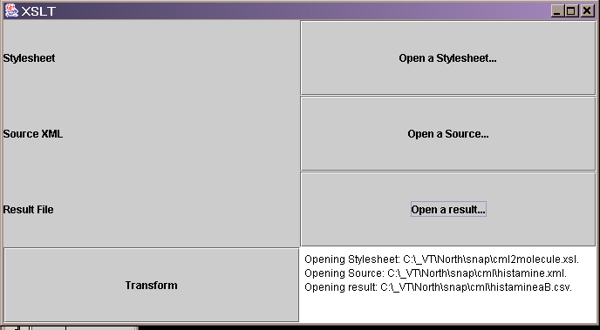
Figure 2. Java XSLT Transformer tool
While building the database, we discovered some limitations in the data model for Snap which has to do with joins. Consider atoms and bonds for example; a bond connects two atoms but from our available data, it does not have a directionality associated with it. For a Snap event to connect an atom and bonds, its bonds or a bond and its atoms, we had to add an intermediary, redundant ‘bond2way’ table even though it makes no sense to claim that one is the start_atom and one is the end_atom.
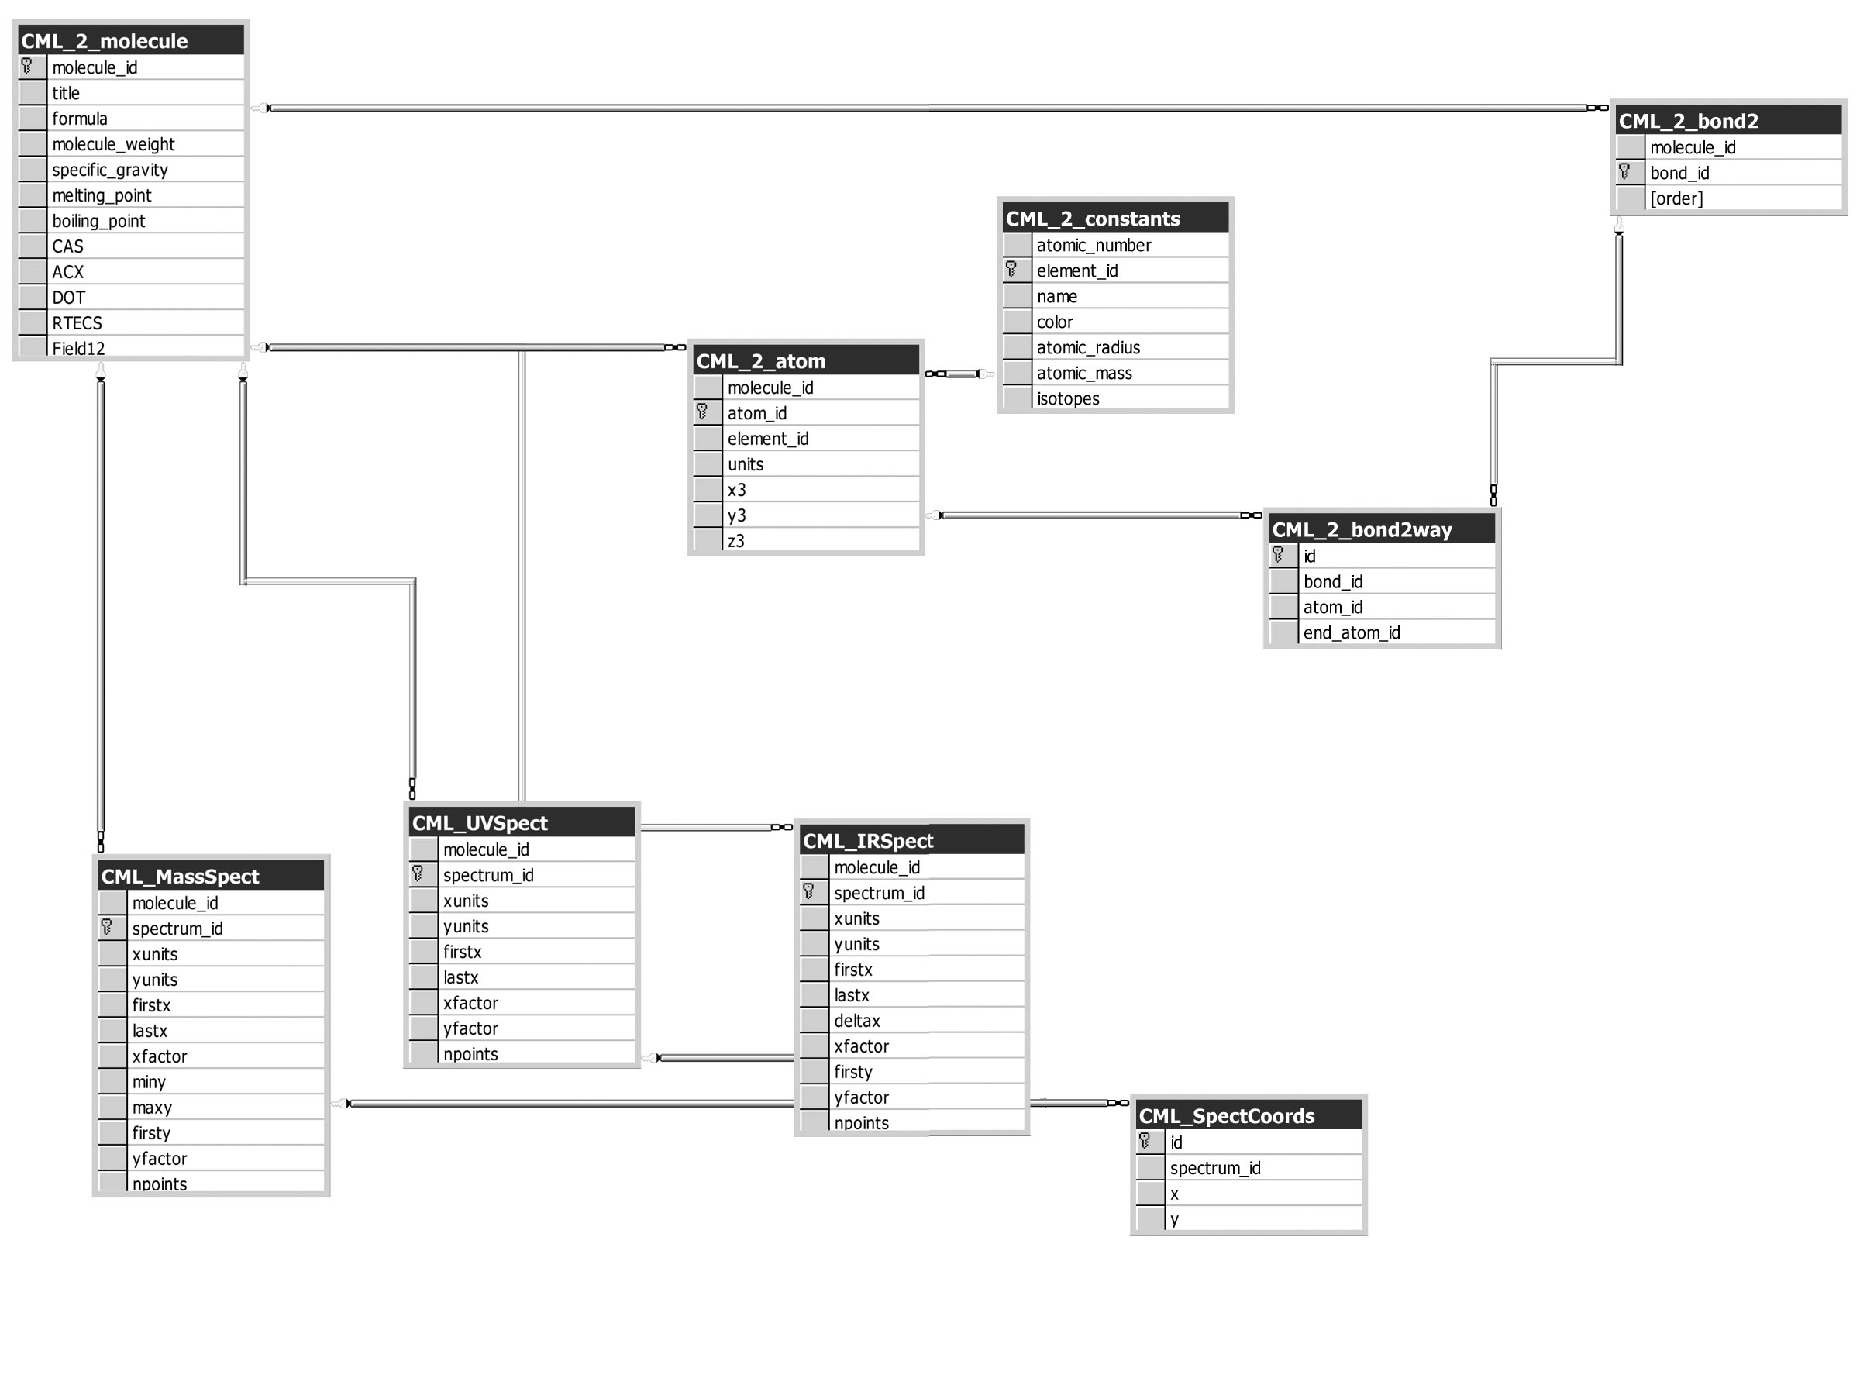
Figure 3. SQL Relationships in Molecules.dsn
Once the data was in the SQL server (see Figure 3), it could be loaded by a Snap application. For this project, we also had to build a CaveAdapter for Snap to process events to the virtual world. Because Snap currently has no event mechanism to declare from which visualization component an event originated, we built the adapter to actually manifest three adapters in the schema: one for a molecule-visualization event, one for an atom visualization event, and one for a bond-visualization event. Figure 4 shows the Snap setup.

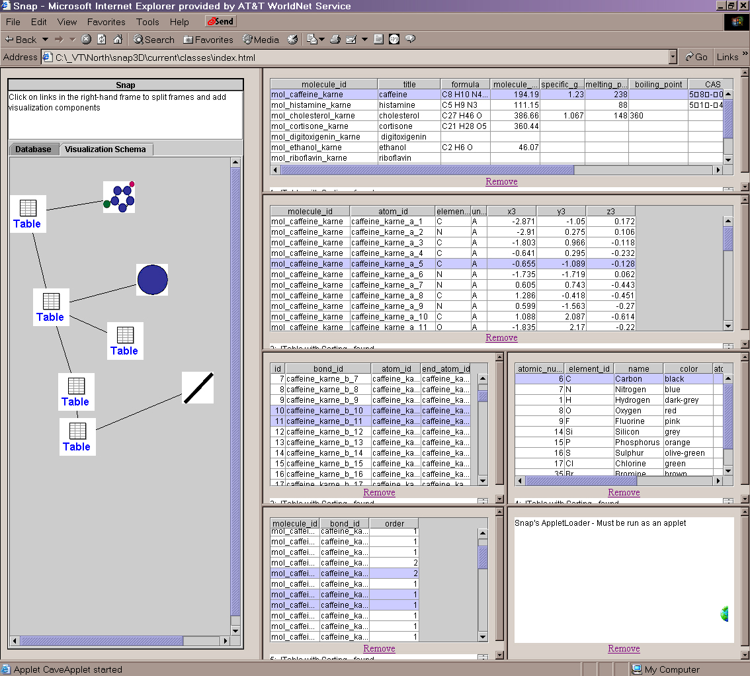
Figure 4. Snap visualization schema with CaveAdapters

3.2 DIVERSE Virtual Environment
S_atomview, our DIVERSE application, was based off of work done during the summer of 2002 by Andrew Ray. His application was developed for materials science and showed large atom fields which changed through time. The structure he used to represent the fields at different time steps was converted to represent different molecules. The previous implementation also did not include any bonds, so this had to be added for each molecule.
When the application starts, it reads in constants for the different elements which are used to scale the atom sizes based on atomic radius. Then geodes are created for each possible color, highlighted and unhighlighted, for the atoms and bonds. These geodes are linked to multiple atoms and bonds to be displayed in the application as spheres or cylinders. Afterwards, the program waits for messages from the Snap side. When a molecule message is received, the program reads the molecule name and appends the file suffix to read the atom, bond, and molecule description text data from a local file. This molecule message also results in reading the molecule’s corresponding color data from a separate file. This color data allows the program to link atoms and bonds to their corresponding geode. Based on the location of other molecules and the base location of the atom, atoms are added to the world. Bonds use the same information as atoms to find its correct position, but it also requires vector calculations to get it lined up between atoms.
Now that a molecule is added, the program waits for more messages. If another molecule message is received, the program removes the molecule if it already in the program and visible. Otherwise, it adds the molecule as before. If an atom or bond message is received, the program searches the corresponding molecule for the object and highlights or unhighlights based on the current state. Molecule description information is also displayed in a heads-up window, and this information changes when you move from molecule to molecule (see Figure 5).
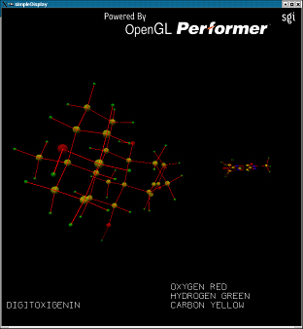
Figure 5. Two X3D molecules in DIVERSE
with Heads-Up-Display
Future work on the DIVERSE side could include adding element letters inside each atom so they can easily be identified, sliders to change the transparency of the atom, and commands to allow easy recentering and movement between molecules. Another focus should be on adding two-way communication back to the SNAP side. This would require developing a mechanism for selection using the wand, which would be somewhat difficult due to the few number of buttons on the wand.

3.3 Snap and RMI messaging
The Diverse ToolKit (DTK) handles messages through its shared memory component. Snap handles interprocess communication within the JVM. Our project wanted to use both of these systems together and they obviously do not mesh well together. If both systems were implemented in Java it might be a little easier, but DTK is a C++ toolkit. Our obvious first reaction was to use CORBA, but we decided this was overkill for the scope of the project that we were doing. We initially decided to try to allow two-way communication between Snap and DTK, but this was beyond the scope of this semester. We decided to use the 3D world basically as a display-only environment that would allow the user to visualize information that they specifically chose from the 2D side of the world. We sent select messages based on molecules, atoms, and bonds from the snap side of the world to the DTK part of the world.
DTK then uses the primary keys that Snap sent over and further process those. The specific way we implemented communication in snap was by using three specially fixed adapters. These adapters received Snap events and then used Java RMI to send the information back to a server that we setup to receive these RMI commands. This computer was enabled with a special DTK program written that Java could run on an RMI invocation. By using the networking features of DTK we were able to then connect the CAVE to this computer and the CAVE would receive the messages from the Snap server. In the future it may be more beneficial to come up with a consolidated way of having one intelligent adapter that can send and receive Snap events from DTK. This would probably be implemented with some form of CORBA or some similar technology.

4 USABILITY EVALUATION

4.1 Procedure
The team members discussed and tried to figure out possible usability issues, the usability tasks to test different aspects of the system and format of the usability study. The subjects were chosen from a cross-section of people, viz.; an undergraduate chemistry student, a graduate computer science student, a material scientist, and virtual reality experts.
The specific aspects which we wanted to evaluate are:
- Viability of a visualization involving 2D and 3D simultaneously,
- User preference based on nature of data, i.e. whether users choose most appropriate visualizations for different types of data.
- Effectiveness of 3D to visualize inherently spatial data as against 2D.
- Use of a novel interaction system XWand, for 2D display in a 3D environment.
The format followed for the usability study was ‘task and response’. The subjects were given a set of tasks to be performed one by one and their feedback was noted. Six tasks were formulated which can be classified into three categories: finding tasks, spatial tasks, and comparison tasks. The finding tasks involved getting the number of atoms or bonds, the spatial tasks were to find out structural features of a complex organic molecule, while the comparison tasks involved similarities and differences between two molecules.
The exact step-by-step procedure was as follows:
- Introduction: The subjects were introduced to the system, the scope and limitations of the system were explained, various interaction techniques were demonstrated, and the procedure was described. The subjects were instructed to think aloud.
- Tasks: The tasks were read out for the subject and their subjective feedback for each task was noted. We also noted down their actions such as where they search for particular information (in 2D or 3D), the problems or discomforts they face with the interaction techniques, etc.
- Closing questionnaire: At the end of the usability study each user was given a closing questionnaire to help reflect their objective opinion about this system.

4.2 Results
Results of the usability study were formed by summarizing the information we obtained from user feedback, user observation and closing questionnaire. They consist of technical deficiencies, usability measures, and suggestions by subjects. One practical limitation of the system is the long setup time. Starting the program, launching a web-browser, loading Snap applets, connecting to a database, creating the relations between the coordinated snap views took 10 to 15 minutes on average. Some technical shortcomings that became apparent during the study include: decrease in the 3D navigation speed as we go on using the wand for 2D interaction, and there is no way to find out the 3D molecular structure in the 3D space if the structure gets lost and the user becomes disoriented, etc.
Usability measures include time to understand the basic concept of coordinated 2D and 3D visualizations, learning time for system interaction, degree to which a new user is overwhelmed by the stimulus of CAVE, etc. For initial questions the most inexperience subject took a long time to answer and also required suggestions from the project team. However, she correctly chose suitable visualizations for different tasks. The use of wand was initially confusing for the subject but she fluently used the wand for toggling between navigation and selection mode, to fly around and to select a record in the later tasks. In culmination of the above lines, learning time was surprisingly low, but the subject was observed to be overwhelmed by the system.
Some important suggestions by the subjects were: two-way selection of atoms (i.e. 2D to 3D as well as 3D to 2D - currently only the first is possible), reducing the size of the 2D browser window or putting it on some hand-held device like a tablet in order to avoid blocking of the virtual world, and using a stylus and tablet interface for faster interaction than the wand. The closing questionnaire showed that the subjects considered this system a better learning device than a textbook and the wand was fairly intuitive as an interaction device. However, the opinion was divided over whether the wand was a hindrance in using Snap window.
After summarizing the results and improving the initial build, we produced an informational video about the project details and filmed it in the CAVE. Also, these results are useful as a guideline for the future work.

5 FUTURE WORK
Future work with Snap could be to relax its datamodel in order to better deal with hierarchical sources, as well as possibly specifying the component of origin in the SnapEvent class. Still, it has proved a useful system to integrate with 3D views and the CAVE.
Our current implementation makes use of the wand and the Hanging Picture to interact with the 2D data of the Snap view. However, usability results for these interaction methods suggested improvements could be made. Selecting from the ‘Hanging Picture’ wall was slow, and it blocked parts of the molecular visualization and could not be minimized. Thus the design and layout of 2D information in a 3D context is still an area ripe for future work.
For our product to be more successful, more interactions techniques should be implemented and evaluated. For example, if the user became lost in the 3D world, there was no way to reset the viewpoint except to reload the application which was not a good option. Also, since we do not have two-way selection implemented from the CAVE view back to the Snap view, future options should be explored including picking touch, laser pointer, and spotlight techniques [FHZ96] [LSH99].

ACKNOWLEDGMENTS
We thank Dr. Chris North and Nathan Conklin for their assistance with Snap. Additional thanks are due Dr. Ron Kriz, John Kelso, and the DIVERSE team for their support in this project.

REFERENCES
[Bender00] Bender, M.; Klein, R.; Disch, A.; Ebert, A. “A functional framework for web-based information visualization systems.” Visualization and Computer Graphics, IEEE Transactions on, Vol.6, Iss.1, 2000, pp. 8- 23.
[BoWi01] Design and evaluation of menu systems for immersive virtual environments
Bowman, D.A.; Wingrave, C.A. Virtual Reality, 2001. Proceedings. IEEE , 2001
[Bow98] Bowman, Doug, Hodges, L., and Bolter, J., “The Virtual Venue: User-Computer Interaction in Information-Rich Virtual Environments”. Presence: Teleoperators and Virtual Environments, 1998. 7(5): p. 478-493.
[Bow02] Bowman, Doug. “Principles for the Design of Performance-oriented Interaction Techniques”. In Handbook of Virtual Environments. edited by Stanney, Kay M. Lawrence Erlbaum Associates. Mahwah, New Jersey, 2002
[BWK00] Baldonado, M., Woodruff, A., Kuchinsky, A. “Guidelines for using Multiple Views in Information Visualization”. Proc. Advanced Visual Interfaces 2000
[CMS99] Card, S., Mackinlay, J., Shneiderman, B.,
Information Visualization: Using Vision to Think, Morgan Kaufmann, 1999.
[Datey02] http://scholar.lib.vt.edu/theses/available/etd-05092002-151043/
[Ebert96] Ebert, D.S.; Shaw, C.; Zwa, A.; Miller, E.L.; Roberts, D.A. “Minimally-immersive interactive volumetric information visualization.” In Proc. of IEEE Symposium on Information Visualization '96, 1996, pp. 66 -67, 123.
[FHZ96]. Forsberg A.; Herndon K.; Zeleznik R. “Aperture Based Selection for Immersive Virtual Environments”. Brown University site of the NSF Science and Technology Center for Computer Graphics and Scientific Visualization.
[LSH99] Lindeman, R.W.; Sibert, J.L.; Hahn, J.K. “Hand-Held Windows: Towards Effective 2D Interaction in Immersive Virtual Environments” Virtual Reality, 1999. Proceedings., IEEE , 1999 Pages: 205- 212
[MICE] The Molecular Interactive Collaborative Environment (MICE): http://mice.sdsc.edu/site/index.html.
[MRR99] Murray-Rust P. and Rzepa, H. S. “Chemical markup Language and XML Part I. Basic principles”, J. Chem. Inf. Comp. Sci., 1999, 39, 928.
[MRW01] Murray-Rust, Peter, Rzepa Henry S., and Wright, Michael. “Development of Chemical Markup Language (CML) as a System for Handling Complex Chemical Content” New J. Chem., 2001, 618-634.
[North01] North, C. Multiple Views and Tight Coupling in Visualization: A Language, Taxonomy, and System. Proc. CSREA CISST 2001 Workshop of Fundamental Issues in Visualization, pg. 626-632, (2001).
[NoSh00] C. North and B. Shneiderman. Snap-Together Visualization: Can Users Construct and Operate Coordinated Views?, Intl. Journal of Human-Computer Studies, Academic Press, 53(5), pg. 715-739, (November 2000).
[NoSh01] North, C. and Shneiderman, B. “Component-Based, User-Constructed, Multiple-View Visualization”. In Proc. of ACM CHI, 2001, pp. 201-202.
[Pol03] Polys, Nicholas F. “Stylesheet Transformations for Interactive Visualization: Towards a Web3D Chemistry Curricula”, Proc.s of the Web3D 2003 Symposium, ACM SIGGRAPH 2003.
[TMB00] Tate, J.G.; Moreland, J.; Bourne P.E. “Design and implementation of a collaborative molecular graphics environment.” Journal of Molecular Graphics, 2000.
[WaFr94] Ware, C. and Franck G. “Viewing a graph in a virtual reality display is three times as good as a 2D diagram”. In A. L. Ambler and T. D. Kimura, editors, Proc. IEEE Symp. Visual Languages (VL'94), pages 182-183. IEEE, 1994.
[WCJ98] Wiss, U.; Carr, D.; Jonsson, H. “Evaluating Three-Dimensional Information Visualization Designs: a Case Study of Three Designs.” Lulea University of Technology Dept. of Computer Science and Electrical Engineering, http://citeseer.nj.nec.com/wiss98evaluating.html, 1998.
[W3C] The World Wide Web Consortium Specifications:
Extensible Markup Language (XML): http://www.w3.org/XML
Extensible Stylesheet Transformations (XSLT): http://www.w3.org/TR/xslt11
[W3D] The Web3D Consortium Specifications:
Extensible 3D (X3D), Virtual Reality Modeling Language (VRML- ISO/IEC 14772:1997) http://www.web3d.org/fs_specifications.htm
X3D TaskGroup: http://www.web3d.org/x3d.html
Software Development Kit: http://sdk.web3d.org

